Hardware Requirements Specification (HRS)
E1001 Carrier PCBA
David D. Clark
December 31, 2024
Revision History
Revision | Date | Changes
X1 |  | Initial draft.

Reference Documents
Document | Source
IEEE 802.3u | https://www.ieee802.org/misc-docs/GlobeCom2009/IEEE_802d3_Law.pdf
Raspberry Pi CM4 datasheet | https://datasheets.raspberrypi.com/cm4/cm4-datasheet.pdf
USB 2.0 Standard | https://www.usb.org/document-library/usb-20-specification
USB Connector for Mezzanine Applications Guidelines Rev. 1.0 | https://www.usb.org/document-library/usb-connector-mezzanine-applications-guidelines-rev-10
IEEE 802.3bt | https://standards.ieee.org/ieee/802.3bt/6749/

Definitions and Acronyms
Acronyms
CM4 | Raspberry Pi Compute Module 4
ESD | Electrostatic Discharge
POE | Power Over Ethernet
RTC | Real Time Clock
SoM | System on module
TVS | Transient Voltage Suppresion
UPS | Uninterruptible Power Supply
USB | Universal Serial Bus

Definitions

Introduction
The hardware requirements for the E1001Carrier PCBA are described in this document. The intent is to capture the minimum set of requirements to ensure that the board will preform as expected in the context of the KG-VRS project.The E1001 Carrier PCBA will meet the requirements described in this document. However the E1001 Carrier PCBA may included features in addition to those described in this document.

PCBA Description
The E1001 Carrier PCBA is a Raspberry Pi compute module based radio node. The node has the capability to include

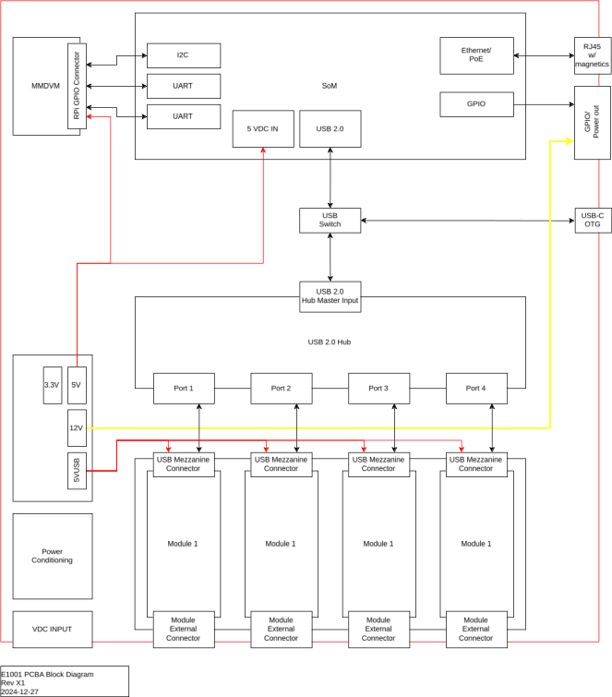
Block Diagram

Requirements

Power Inputs
Requirement | Description | Reference
 | The E1001 Carrier PCBA shall accept a voltage input range of 5 VDC to 24 VDC.
 | The E1001 Carrier PCBA shall provide a circuit for reverse polarity protection on the DC input.
 | The E1001 Carrier PCBA shall provide a fuse on the DC input for over current protection.
 | The E1001 Carrier PCBA shall provide a circuit to indicate that the over current protection fuse has failed.
 | The E1001 Carrier PCBA shall provide ESD suppression on the DC input.
 | The E1001 Carrier PCBA shall provide a common mode choke between the supplu voltage and ground on the main voltage input.
 | The E1001 Carrier PCBA shall provide an Ethernet interface capable of POE.

Derived Power Rails
Requirement | Description | Reference
 | The E1001 Carrier PCBA shall provide a +5 VDC power rail.
 | The E1001 Carrier PCBA +5 VDC rail shall be capable of sourcing xx A
 | The E1001 Carrier PCBA shall provide a +3.3 VDC rail
 | The E1001 Carrier PCBA +3.3 VDC rail shall be capable of sourcing xx A.

Grounding
Requirement | Description | Reference
 | The E1001 Carrier PCBA shall have a single point ground.
 | The E1001 Carrier PCBA single point ground shall be located on the input to the power conditioning common mode choke. | E1001:REQ:4.1.6
 | The E1001 Carrier PCBA analog and digital signals shall be referenced to the output of the common mode choke. | E1001:REQ:4.1.6
 | The E1001 Carrier PCBA derived power rails shall be referenced to the output of the common mode choke. | E1001:REQ:4.1.6

Power Outputs
Requirement | Description | Reference
 | The E1001 Carrier PCBA shall provide a 12 VDC output.
 | The E1001 Carrier PCBA shall be exposed to an external port.
 | The E1001 Carrier PCBA shall 12 VDC output shall be capable of supplying xx A to an external load connected to the 12 VDC port.

MCU
Requirement | Description | Reference
 | The E1001 Carrier PCBA shall use a Raspberry Pi Compute Module 4 CM410802 as the SoM.
 | The E1001 Carrier PCBA shall be capable of of flashing an image to the eMMC storage of the SoM using an external host computer.

GPIO
Requirement | Description | Reference
 | The E1001 Carrier PCBA shall expose nn GPIO pins.
 | The exposed GPIO pins shall be 5V tolerant.

Communication
Requirement | Description | Reference
 | The E1001 Carrier PCBA shall expose the Ethernet port on the SoM.
 | The E1001 Carrier PCBA shall expose the USB 2.0 bus on the SoM.
 | The E1001 Carrier PCBA shall expose the USB OTG port of the SoM.
 | The E1001 Carrier PCBA shall expose the USB OTG port via a USB Type-C connector.

Peripherals
Requirement | Description | Reference

Mechanical
Requirement | Description | Reference

User Interface
Requirement | Description | Reference

GPIO Connector
Requirement | Description | Reference
 | The E1001 Carrier PCBA shall provide an external GPIO connector for the exposed GPIO pins on the SoM. | E1001:REQ:4.6.1
 | The E1001 Carrier PCBA GPIO connector shall provide at least one +12VDC output pin. | E1001:REQ:4.6.3
 | The E1001 Carrier PCBA GPIO connector shall provide a ground pin for each GPIO pin.

USB Module Interfaces
Requirement | Description | Reference
 | The E1001 Carrier PCBA shall provide interface circuits for four USB 2.0 based interface modules.
 | The E1001 Carrier PCBA USB 2.0 interface modules shall use the same connector and the same pinout to connected to the SBC module.
 | The E1001 Carrier PCBA shall implement a circuit to provide +5 VDC to each interface module board.
 | The E1001 Carrier PCBA shall implementa circuit to provide 1 A of current to each module interface board.

MMDVM Interface
Requirement | Description | Reference
 | The E1001 Carrier PCBA shall provide an interface to accept a standard MMDVM PCBA

UPS
Requirement | Description | Reference
 | The E1001 Carrier PCBA shall provide a UPS circuit capable of running the SoM after power has been lost from the main power input or the POE input.
 | The UPS shall be capable of powering the E1001 Carrier PCBA for xx minutes.

Real Time Clock
Requirement | Description | Reference
 | The E1001 Carrier PCBA shall provide an RTC for the SoM.

Feature
Requirement | Description | Reference

